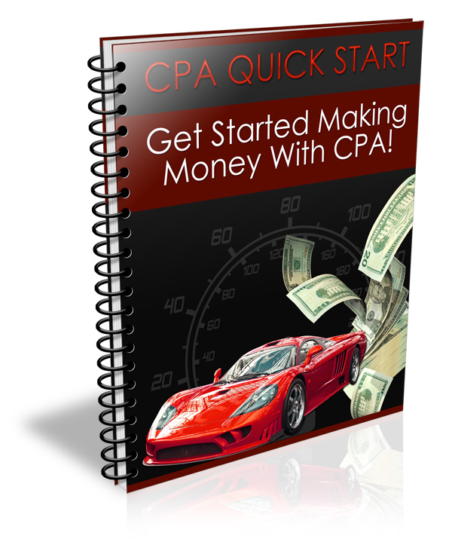
This Report Has Been Brought To You By:

www.YourDomain.com

TABLE OF CONTENTS

What is CPA? 3
Why Is CPA So Popular? 4
CPA Terminology 5
Making Money With CPA Opportunities 6
Choosing The Best CPA Offers 7
Important Factors to Consider 9
Promoting CPA Offers 11
CPA Companies 12

What is CPA?

CPA or Cost Per Action is an online business model, which pays out for every action completed by the consumer. Advertisers will pay YOU when a consumer gives his email, zip code, opts in for a free trial, or supplies relevant information pertaining to their campaign.

CPA is one of the most popular methods of making money online through your website, blogs, or newsletters.

This strategy is a bit different from the Adsense program where one is paid when a visitor clicks on an advertisement. CPA often requires specific action.

As you will discover while learning the ins and outs of CPA campaigns, the more actions required from a user typically equates to a higher potential to earn.

For example, you may be paid $1.00 for every email address compiled from visitors to your website signing up for a free report, while you could earn $50 or more from the same person purchasing a product or subscription.

Why Is CPA So Popular?

Cost Per Action marketing is one of the best channels to explore if you are interested in generating an extra stream of income, even if you are brand new to online business and Internet Marketing.
Here are just a few reasons why CPA campaigns and opportunities are so appealing:

- No need to generate sales in order to earn.

- No need to do cold calling or massive ad campaigns that typically require a lot of upfront costs and investment.

- Advertisers design their campaigns to convert. Market research and testing is usually not required at all. Your job is to generate traffic to their offers.

- No experience required: CPA Marketing is something that anyone can become involved in, regardless of location, experience or knowledge.

- Promotional Media Provided: Many companies will provide you with all of the promotional tools and media that you need, eliminating any requirement of designing web pages.

CPA Terminology

YOU will encounter different terms when you go deeper into the CPA Marketing world. Here are the more common ones:
Affiliate Vs. Merchant

You are considered an affiliate when you participate in CPA opportunities where you are paid on a commission basis.

Campaign

A campaign is a promotion that you will run or participate in. Each campaign pays out based on a different action.

CPA Network

The “network” is the company offering CPA opportunities.

Per Lead or Per Sale

Pay per lead is when you earn money for every new lead generated by your marketing efforts. You do not need to sell anything in order to earn with PPL. With Pay Per Sale (PPS), you must generate a sale in order to be eligible to receive commissions, based on a flat fee or percentage basis.

Making Money With CPA Opportunities

Evaluate your target audience
You need to understand your market if you wish to do well with CPA opportunities. By knowing what types of campaigns and promotional offers your website visitors would be interested in, you are able to effectively set up targeted campaigns that will convert.
Are your visitors interested in free magazine subscriptions? If so, what genre would they primarily be interested in? Survey your website visitors, ask them what they are interested in and use that information to select appropriate campaigns.
Be Flexible
Don’t just choose one CPA campaign and stick to it, be open to exploring all of the many opportunities available. Spend time experimenting with different lead generation tactics, create squeeze pages, and subscribe to multiple CPA opportunities so that you can thoroughly evaluate what campaigns will work best for your website.

Read The Rules
Don’t venture into CPA without first learning the strategies that have worked for seasoned marketers, and save yourself time and money by structuring a step-by-step system that will help you maximize your traffic and revenue.

Make sure that you understand the guidelines, rules and any restrictions that may be in place. Often times, CPA companies require specific information in order for you to be credited with a lead or sale. In addition, there are specific methods of advertising that may be considered misleading, going against the terms of service of most of the established CPA companies, so always read over the guidelines and follow them.

Choosing The Best CPA Offers

When you first get started with CPA, you will quickly notice how certain opportunities generate better results than others. It’s important to always stay on top of the campaigns that you are involved in, so that you are generating the highest conversions for the time and money you put into your marketing efforts.
While CPA can run on auto pilot once you have your system in place, you will have to roll up your sleeves and get your hands dirty when first starting out. Create a system where you are able to review your progress each day, weeding out ineffective campaigns and tweaking campaigns that are working well.
When choosing CPA offers that appeal to you, do some online research to determine if other marketers have been successful with these offers as well as the methods that they are using to promote these campaigns successfully.

When evaluating a CPA offer, there are a few things to keep in mind:
1) Less Action Equals More Money
Obviously the less that a visitor or subscriber has to do, the better. If you are being paid for every email address entered in an online form, you will make more money than campaigns that require a user to complete a series of steps.

When you are first starting out with CPA, choose simple campaigns, so that you can get a feel for how your audience responds to your offers, as well as how CPA marketing works.
2) Free Offers
People love receiving free gifts, trial offers, subscriptions and so on, and these are quite often some of the easiest CPA opportunities available that will generate quick cash for very little work. After all, you are giving people something for free, eliminating any pre-selling.

Important Factors to Consider

Research your target traffic. Know how to dig down into your market and know exactly how to determine what campaigns are likely to yield instant results.

Evaluate niche markets, methods of generating targeted traffic and blend CPA opportunities with specific groups of people, so that you are offering them exactly what they are looking for.

Evaluate your websites and marketing campaigns from their perspective. Does it sound good? Believable?
Ask yourself from the perspective of a consumer. Would you sign up for your own offer? Would you be enticed to provide your email address in exchange for what you are offering? Avoid hype or gimmicks and let people know exactly what to expect and what they are required to do in order to receive what they are being offered.
Keep it Simple
Set up your campaigns so they are comprehensive and easy. You want your visitors to go through the process quickly and error free. Whenever you set up a poll, a list or an opt-in form, be sure to go through the steps yourself to ensure that there are no problems, broken links, images or pages.

Participate in campaigns with existing promotional material that has been tested and proven to convert. These will save you a lot of time and effort, because the bulk of the work has already been done for you. Evaluate it once again, from a consumer’s perspective. Is it attractive? Clear? Comprehensive?

Go for something that is not commonly promoted. Think of how the competition will be and balance out the risk of getting fewer conversions by participating in campaigns that are less promoted, especially when starting out. Timing is of the essence for CPA marketing like any other business. It will also be good to be among the first to market a new offer.

Promoting CPA Offers

Once you have chosen the CPA offers that you want to market, commit to marketing it and following through with your strategy, even if the results are slow yielding at first.

If you have a website, make good use of it to push by integrating CPA offers into your existing pages.

Make sure that the CPA offer blends well with the purpose of your website. Do not make the mistake of featuring an off-targeted advertisement, or not properly evaluating your market.

Lead generating or squeeze pages are also excellent channels for CPA marketing. Free ebooks, reviews, and other free digital goods can be given away to help build the confidence of your target market and encouraging them to follow through with various CPA offers.

Once you become more comfortable with the various aspects of CPA marketing, you will be more confident in exploring the different offers and discovering new ways that will help you maximize your income, so take it one step at a time.

CPA Companies

http://www.pythonmedia.com/
http://www.revenuegateway.com/
http://rextopia.com/
http://www.thebizoppnetwork.com/
http://trafficneeds.com/
http://www.valueclick.com/
https://neverblueads.com/
http://www.primaryads.com/
http://www.commissionsoup.com/
http://webjamads.com/
http://www.revenueloop.com/
http://www.partnerweekly.com/
http://login.offerweb.com
http://www.addrive.com
http://www.linkvalu.com/
http://www.incentaclick.com/
http://www.cpaempire.com/
http://www.azoogleads.com
http://www.hydranetwork.com/
http://www.marketleverage.com/
http://www.netmargin.com/
http://www.ethosinteractive.com/
Looking For A Step By Step Blueprint
To Making Money With CPA Offers?
Visit www.YOURDOMAIN.com
And Download A Complete Guide
To CPA Profits!

